The scientists are saying the water levels of all rivers are decreasing through the years and they are going to keep going down. They say the reason for this a steady grow of population and climate changes. Farming is how it all began because they built irrigation systems and when they plant their crops it consumed 70 percent of the river basins water. Of course the cities take some of the water and other parts of it evaporate into the air. He is also saying that the Colorado River doesn’t reach the sea anymore but it will never run dry.
Researchers have suggested a way to stop wasteful spending of water and it is by not spending water on random ideas and example is in Vegas the giant fountains in front of the giant hotel. You can also not use as much water on your lawn.
There was a mystery fish that an angler in Borneo caught. It is covered in shard spines on the top and bottom of its body. The head is very big with the fail is a lot smaller. It also has 2 tusks in the front near its mouth.
The way they are trying to find it is Zeb Hogan, a national geographic contributor, fish expert, and assailant at Nevada University. He wasn’t sure but he reached out to Gene Helfman, a fish expert at Georgia. They say it is a perestidiid armored gurnard. The wife of the person who caught it is going to dry it and keep it as a reminder.
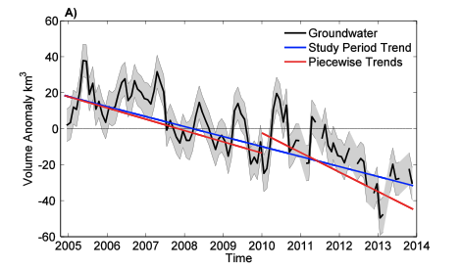
Water is important to all life because everyone needs water and so does everything. It gives life by, obviously, giving water to people and plants which we need. Freshwater is only 3% of earths water and we use a lot of that on our lawns and in useless things. We can fix this by not using water on useless things like fountains and turn off running water when no one is using it. You can also let the rain water you lawn instead of using a hose. This graph shows how everything about the Colorado River is going down. Amount of ground water, the study period, and piecewise trends.
